Practical
SUMMARY:-
The making a change problem uses dynamic programming to find the minimum number of coins required to make a given amount. It stores previous results in a DP array to avoid repeated calculations.
Output:
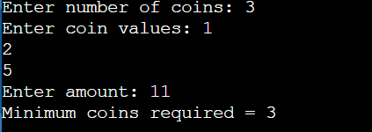

Time Complexity:
Case | Time Complexity
Best Case | $$O\left(nA\right)$$
Average Case | $$O\left(nA\right)$$
Worst Case | $$O\left(nA\right)$$
Where, $n$= number of coin types and $A$= target amount.

Space Complexity:
$O\left(A\right)$, using a one-dimensional DP array.

Conclusion:
Thus, the making a change problem was successfully implemented using dynamic programming to find the minimum number of coins required for a given amount.

